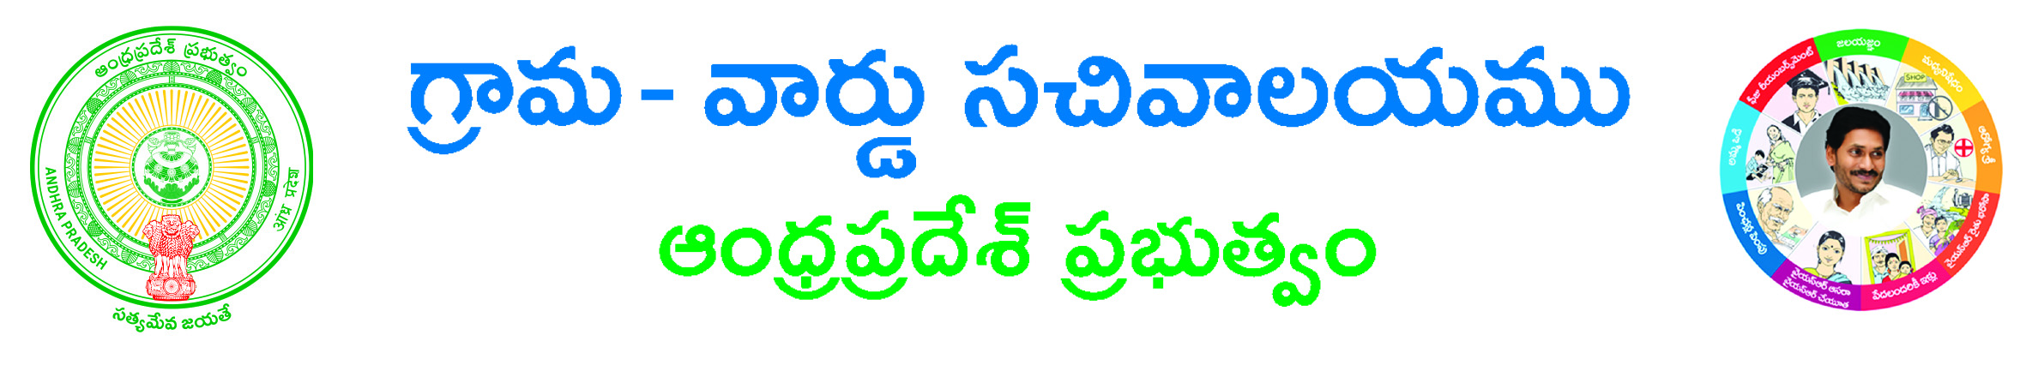**CHANGE OF NAME APPLICATION FORM**

**Type of Application: 🞏 Major 🞏 Minor**

**Applicant Details:-**

**Applicant Present Sur Name*: _________________________Applicant Proposed Sur Name*: _________________________________**

**Applicant Present Name*: ________________________________ Applicant Proposed Sur Name*: ____________________________**

**Gender*: 🞏 Male 🞏 Female Marital Status*: 🞏 Single 🞏 Married 🞏 Widow 🞏 Widower 🞏 Divorced  
Father Name*: _____________________ Mother Name*: ____________________ Husband/Wife Name: _______________________**

**Police Station Name having jurisdiction*: ________________________ Age*: ________ Place of Birth*: ______________________**

**District*: ____________________________________________ Mandal*: _________________________________________________ Village/Ward*: _______________________________________ Locality/Landmark*: ________________________________________ Door No*: _________________________Pin code: _________________________**

**Occupation Details: - (For Major Only)**

**Profession*: 🞏 Government Employee🞏 Non Government Employee 🞏 Others**

**Government Employee Details:-**

**Name of the Employee*: _________________________________________ Name of the Department*: _________________________ Designation*: _____________________________ Date of Appointment*: ____________________________**

**Non Government Employee Details:-**

**Name of the Employee*: ________________________________________ Name of the Company*: ____________________________ Designation*: _______________________________ Date of Appointment*: _______________________________**

**Company Address*: _____________________________________________________________________________________________**

**Others:-**

**Mention your Employment*: _____________________________________________________________________________________**

**Occupation Details: - (For Minor Only)**

**Mention your Work/Education*: __________________________________________________________________________________**

**Informant Details:-**

**Informant Name*: ____________________________________________ Relationship with Applicant*: _________________________**

**Mobile No.*: _____________________________ Email ID: _____________________________________________________________ Delivery Type*: 🞏 At Kiosk 🞏 Post Local 🞏 Post Non-Local**

**Postal Details:-**

**State*: __________________________District*: _______________________ Mandal*: _____________________________________ Village/Ward*: _________________________________________________ Door No: _______________________________________ Pin code: _______________**

**Documents List: - (Documents PDF format only)**

**🞏 Application Form\***

**🞏 Recent Passport size Photograph *(JPG/JPEG/PNG/GIF format only)**

**🞏 Citizenship Certificate issued by Gazetted Officer\***

**🞏 Affidavit stating exact reason for change of his/her name\***

**🞏 Certificates from Class 1 to 10th attested by Gazetted Officer**

**🞏 Police Certificate stating that he/she has not come to any adverse records during last 5 years\***

**🞏 Others (Aadhar/Ration Card/VoterID etc for Illiterates) Applicant’s Signature**

**(* - Indicates Mandatory)**